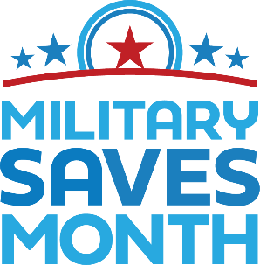
2021 MILITARY SAVES MONTH & (Insert Organization/Installation Here)
BY (TITLE OF OFFICIAL MAKING PROCLAMATION)
A PROCLAMATION
WHEREAS, personal and household savings is fundamental to (name of organization/installation or community)’s stability and vitality; and
WHEREAS, adequate emergency savings, retirement funds, and safe debt‐income ratios are critical components of personal financial security; and
WHEREAS, Military Saves is a national campaign to persuade, encourage, and motivate members of the military community to take financial action in building wealth through saving money and reducing debt;
WHEREAS, (name of organization/installation or community) is a partner in the Military Saves campaign and is committed to helping its (service members, citizens, clients, customers, and/or employees) take immediate financial action to Build Wealth, Not Debt;
NOW, THEREFORE, (I, Name, Title, or name of governing body) do/does hereby proclaim April 2021 as
(Organization/installation or community) MILITARY SAVES MONTH
AND DO DECLARE
I/WE HEREBY call upon all (service members, citizens, clients, customers, and/or employees) to set a personal savings or debt reduction goal, make a simple savings plan, and act on that plan, or take another positive wealth-building action during MILITARY SAVES MONTH, and pledge to sustain that action during the following year.
IN WITNESS WHEREOF, I/we have hereunto set my/our hand(s) this (date) day of (month), 2021.
(Signatures)

